**Experiment - 1.3(b)**

**Student Name: Milan Sharma UID: 23MAI10003**

**Branch: ME – CSE - AIML Section/Group: MAI – 1 (A)**

**Semester: 1st Date of Performance: 29 Aug 2023**

**Subject Name: Python Programming Subject Code: 23 CSH 623**

1. **Aim of the Experiment :**

Write a python program to check whether the number is Armstrong or not.

1. **Objective of the Experiment :**

To check whether the number is Armstrong or not.

1. **Algorithm/ Steps for Experiment :**

1.        Start

2.        Declare Variable sum, temp, num

3.        Read num from User

4.        Initialize Variable sum=0 and temp=num

5.        Repeat Until num>=0

6.        sum=sum + cube of last digit i.e[(num%10)*(num%10)*(num%10)]

7.        num=num/10

8.        IF sum==temp

9.        Print "Armstrong Number"

10.      ELSE

11.      Print "Not Armstrong Number"

12.      Stop

1. **Code for Experiment :**

num = int(input("Enter a number: "))

sum = 0

temp = num

while temp > 0:

digit = temp % 10

sum += digit ** 3

temp //= 10

if num == sum:

print(num,"is an Armstrong number")

else:

print(num,"is not an Armstrong number")

1. **Result/Output :**

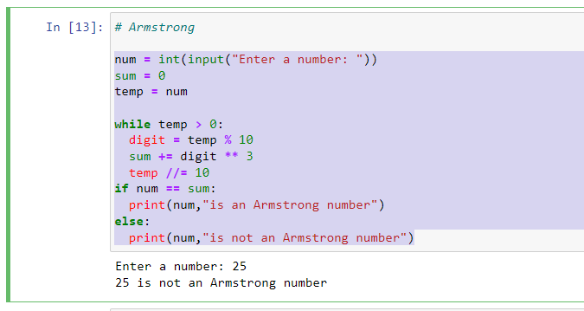

1. **Learning outcomes (What I have learnt):**

1. Learnt what is Armstrong Number

2. Learnt the use of while loop